

Admissions Policy 2027-28
Crowmoor Primary School
Martin Wilson Primary School

Policy Version Control

Policy Type | Statutory Trust Document
Author | Governance and Compliance Manager
Approved By | Trust Board
Approved Date | TBC
Date of next review | Annually
Version | 1
Description of changes | This is a new policy

- Legal Framework and Guiding Principles

  - SHINE Academies is a multi-academy trust consisting of six schools in the West Midlands. Our Trustees are the admissions authority for all our schools, and they apply all aspects of the regulations and procedures detailed in this policy fairly and equally to all those who wish to attend one of our schools.

  - SHINE Academies operate two separate Admissions Policies as follows:
Policy a)
Busill Jones Primary School
Lodge Farm Primary School
Northwood Park Primary School
Villiers Primary School

Policy b)

Crowmoor Primary School
Martin Wilson Primary School

  - This policy has due regard to the following legislation and any regulations thereunder:

- The School Admissions Code (2021)
- The School Admission Appeals Code (2022)
- The Equality Act (2010)
- The Human Rights Act (1998)
- The School Standards Framework Act (1998)

  - All children with an Education, Health and Care Plan (EHCP) that specifies a SHINE school as their preferred school will automatically be admitted. Information on each school’s local SEN offer can be found on the individual schools’ website.

  - Where fewer applications are received than the number of places available for the relevant age group (i.e., the normal age that pupils are admitted to the school), all applicants will be offered a place.

  - Where there are more applications than places for a relevant age group, the oversubscription criteria detailed in section 5 will be used to determine which children are offered a place.

  - The Board of Trustees for SHINE Academies is responsible for monitoring the application of this policy to ensure fairness and consistency across the Trust.

  - For the purposes of this policy, working days are defined as the relevant days that the school which has been applied for is open to pupils.

- How to Apply for a Place at a SHINE school

  - If you are applying for a place during the normal admissions round, you should use the online portal provided by the local authority for the area in which you live (known as your home local authority).

  - The normal admissions round refers to applications to start at the school in the appropriate age group and when other children are normally admitted. Please see Section 3 for details regarding in-year admissions and Section 11 for how we deal with other specific circumstances.

  - Some local authorities refer to the application form as a Common Application Form (CAF) and many now provide the option to apply online. You should check the application process for your home local authority by visiting their website. Ensure that you submit your application either in writing or online, but not by both methods. The below are the links to the Local Authorities for each school within the Trust:

Busill Jones Primary School School admissions | Walsall Council
Crowmoor Primary School School admissions | Shropshire Council
Lodge Farm Primary School School admissions | Walsall Council
Martin Wilson Primary School School admissions | Shropshire Council
Northwood Park Primary School School admissions | City Of Wolverhampton Council
Villiers Primary School School admissions | City Of Wolverhampton Council

  - The deadline for applications during the normal admissions round, to take up a place in September 2027, is 15 January 2027 for admissions into Reception.

  - Applications received after the deadline will be treated as late applications and considered in accordance with the relevant home local authority’s co-ordinated scheme. Details of this will also be available on your home local authority’s website.

  - Applications submitted later than the start of the academic year (after 1 September 2027) must be submitted as an in-year admission (please see section 3).

  - For admissions into any year group other than Reception, on or after the deadline, please also see section 3 of this policy.

- In Year Admissions

  - In-year admissions occur when an application for admission is made outside the normal admissions round. Since 1 September 2021, all in-year admissions are conducted by the local authority, however the view of the individual school is always taken into account.

  - For all our schools, initial applications for in-year admissions should be made directly to the local authority.

- How Many Pupils Will Be Admitted?

  - Each school has set the number of pupils that will be admitted during the normal admissions round. This number is the Published Admissions Number (PAN). PAN therefore only applies to the usual points of entry in a school. For schools within SHINE Academies this is Reception only.

  - If the number of applications received for an school exceeds the PAN, the oversubscription criteria will be used to determine which pupils are allocated a place.

  - The PANs for our schools are listed below:
Busill Jones 45
Crowmoor Primary School 30
Lodge Farm Primary School 60
Martin Wilson Primary School 30
Northwood Park Primary School 90
Villiers Primary School 90

- Oversubscription Criteria

  - If there are more applications for places than there are places available, we will give preference to children according to the criteria in 5.1.1 – 5.1.5.

A child with an Educational Health and Care Plan (EHCP) which names the school will be admitted. Remaining places are allocated as detailed below.

5.1.1. Priority 1: 'Looked after child' or a child who was previously looked after but immediately after being looked after became subject to an adoption, child arrangements, or special guardianship order including those who appear to the school to have been in state care outside of England and ceased to be in state care as a result of being adopted.

Supporting Evidence

If the child is in the care of a local authority or provided with accommodation by that authority this must be indicated on the common application form and evidence (e.g. evidence of child in care from the placement authority) to support this claim must be submitted with the common application form. If the child has previously been in the care of a local authority or provided with accommodation by them and has subsequently been adopted or is subject to a child arrangements order or special guardianship order this must be indicated on the common application form and evidence (e.g. adoption certificate/copy of court order) to support this claim must be submitted with the common application form. For children in state care outside of England who ceased to be in state care as a result of being adopted the relevant legal document(s) must be supplied.

Where there are fewer applicants than the PAN, all children will be offered a place. In the event the school is oversubscribed, the admission authority will apply the following oversubscription criteria in order of priority.

5.1.2 Medical/Social

Very exceptionally, priority may be given to a child who has a particular health reason requiring them to attend a specific school. This will only be allowed if parents/carers provide written evidence from a medical professional that in the view of the authority confirms that attending that particular school (and no other) is essential to the medical well-being of the child. The admission authority reserves the right to contact medical professionals to ascertain the relevance of the medical condition.

5.1.3 Children Living In Catchment

Children living inside the designated catchment area will have priority of admission. If there are not enough places for all the children in the catchment area, then the following criteria for admission will apply in order:

- Priority will be given to children living within the catchment area who will have an older sibling at the school on the day they are due to start school
- After that, priority will be given to other children who live within the catchment area

5.1.4 Children of Members of Staff Working at the School

Children of a member of staff employed at the school:

- Where a member of staff who has been employed at the school for two or more years at the time at which the application for admission to the school is made.
- A member of staff is recruited to fill a vacant post for which there is a demonstrable skill shortage.

5.1.4 Other Criteria

If there are spaces still available after the above criteria have been applied, children living outside the designated catchment area will be offered places according to the following criteria:

- Children who will have an older sibling at the school on the day they are due to start school.
- All other children.

- Notes and Application of Oversubscription Criteria

  - A sibling connection is defined as a brother or sister, step-brother or step-sister, half-brother or half-sister, living at the same address as part of the same family unit and of compulsory school age (i.e. 5 – 16 years). Fostered and adopted siblings are also included. Siblings must be attending the school on the date the younger sibling is due to start there. However, cousins or other relatives who take up residence in a home in order to establish an ‘in catchment area’ address will not be given priority under the sibling criterion.

  - For admission purposes all distances are measured as a straight-line distance on a computerised mapping system between the home address and the nearest entrance gate of the relevant school by pinpointing their eastings and northings. The shortest distance being given highest priority.

  - Where two addresses are within the same block of flats, the lowest number of flat nearest the ground floor will be deemed to be the nearest in distance.

  - In the normal admissions round, applications for children moving into Shropshire Council’s area can only be considered when formal confirmation (e.g. signed tenancy agreement when no property is owned, or exchange of contracts) of the address has been received.

  - All applicants are required to give correct information about the genuine residential address of the child.

  - Where any information regarding a home address is found to be fraudulent or misleading a school place may be withdrawn even if the child has been admitted to the school.

  - In the event that two applications are exactly the same after all other criteria have been considered a tie breaker will be used. This will be by random allocation and overseen by an independent party not connected with the admissions process.

  - We will accept changes to the address up to the point of the application submission deadline. Please note, the deadline for applications is 15 January 2027. Applications received after this date will be treated as late. Applications received after the closing date and before the final date for late submissions (6 March 2027) will be considered if the late submission is for a valid reason or parents can demonstrate a material change in circumstances, for example due to a change of address.

  - If unsuccessful on allocation day, a child will automatically be added to the waiting list of their preferred school. Should a vacancy become available the highest ranked application held in accordance with the published oversubscription criteria will be offered a place at the school by Shropshire Council on behalf of the trust.

For more information regarding the admissions process the Council publishes a booklet each year
“Parent’s Guide to Education in Shropshire” with up-to-date information about schools and how the admissions processes work. Booklets are available along with a copy of the arrangements on the Council’s website www.shropshire.gov.uk.

If you wish to speak to the admissions team, you can contact them as follows:

www.shropshire.gov.uk

school-admissions@shropshire.gov.uk

Tel: 0345 6789008
Admissions Team Learning & Skills
Shropshire Council
The Guildhall, Frankwell Quay, Shrewsbury, SY3 8HQ

- When Do I Find Out If My Child Has Been Offered A Place?

  - If you have applied using the CAF or online portal, and your application was submitted by the deadline, you will receive notification from your local authority advising you of the school your child has been allocated. Notifications will be issued on 16 April (National Offer Day) or the next working day for Reception applications.

  - For late applications, you will receive a notification from the local authority advising you of the school your child has been allocated on the date specified by the local authority’s policy on late applications.

  - Representatives of the school or our Trust are unable to comment on any application prior to the above dates.

  - Once a place has been allocated at the school, the school will contact you to provide further details of the induction process.

- What Happens If My Child Has Not Been Allocated A Place?

  - If your child has not been allocated a place at one of our schools, their name will be added to our waiting list until at least the end of the academic year in which the application has been made. Each time a child is added to a school waiting list, it is re-ranked in accordance with the School Admissions Code. In the June following the allocation, any children still on the waiting list for a place are emailed with a link to request their child be placed on the waiting list for the following academic year.

  - You also have the right to appeal the decision (see Section 10).

- Waiting Lists

Admissions to Crowmoor and Martin Wilson Primary Schools are managed by Shropshire Council, on behalf of the Trust and they hold any and all waiting lists. The waiting lists for all year groups are held and maintained on the school’s behalf by Shropshire Council for the academic year. The waiting list are held in strict accordance with our published oversubscription criteria and reranked after each additional child is added to the waiting list.

Should a vacancy become available the highest ranked application held in accordance with the published oversubscription criteria will be offered a place at the school by Shropshire Council on behalf of the Trust. Once offered, the school place must be taken up within 6 school weeks.

- Appeals Against Admissions Decisions

Any applicant refused a place at a SHINE Academies school, has a right of appeal to an independent appeal panel in accordance with the School Admission Appeals Code. The Trust is responsible for setting up the appeal and must do so in accordance with the School Admission Appeals Code. The panel must be independent of the school.
SHINE has arranged for Shropshire Council to administer admissions appeals on its behalf for Crowmoor Primary School and The Martin Wilson School. Parents/carers wishing to appeal should do so via the Shropshire Council Website https://shropshire.gov.uk/school-admissions/application-results-and-appeals/appeal-against-allocati…

The Trust has to ensure that the independent appeal panel is trained to act in accordance with all relevant provisions of the School Admission Appeals Code published by the Department for Education. If, after your appeal, you are concerned that the appeal did not comply with the Code or was set up wrongly, and that this affected the outcome of your appeal, you can complain to the DfE. The DfE will investigate the complaint on behalf of the Secretary of State. If the DfE finds that the appeal arrangements have breached the Code, the academy may be required to establish a fresh appeal to hear your case if DfE finds that any breach may have affected the outcome of the appeal.

Complaints to www.gov.uk about the appeal panel process should be submitted by completing Online Complaints Form. Using the online form is the quickest way to make a complaint. If you need a paper form instead, contact the Department for Education helpline on 0370 000 2288 (Monday to Friday, 9:30am to 5pm).

- Exceptions And Specific Circumstances

When can my child start school?

Children can attend primary education from the September following their 4th birthday. The law requires that children attend school from the prescribed day following their 5th birthday. Parents can request that the date their child is admitted to the school is deferred until later in the school year, or until the child reaches compulsory school age in that year. They can also request that their child attends part-time until they reach compulsory school age. However, the offer of a place cannot be held over until the next academic year.

NB: Children become of compulsory school age on the first prescribed day following their 5th birthday: 31 August, 31 December or 31 March (or on that day if any of these dates are the child’s birthday).
Shropshire Council does not offer the option for a child to start primary school before they are eligible.

Deferred Transfers

Children born from 1 April to 31 August – known as summer born children – do not need to start school until the September after their fifth birthday, a year after they could first have started school. Most summer born children start at age 4 with no issues.

Parents of summer born children have two options if they feel their child is not ready to start Reception with their natural cohort. These are outlined below:

Option 1 - Delayed Start

If a parent of a summer born child does start school aged 4, they can, if they wish, agree with the allocated school a pattern of part time attendance or a deferred start until later in that school year for your child. You can discuss this with the school. This will require the parent to apply on-time (by 15 January) using the application process provided by Shropshire Council. Once places are allocated on the 16 April the parent can contact the Headteacher to discuss the delayed start.

Option 2 - Defer for a full year

If a parent decides their summer born child will start school aged 5 and wants their child to start school in reception (not Year 1), they need to make a request to the school’s admission authority. This is called requesting admission out of the normal age group – because children born from 1 September in one year to 31 August the following year are normally educated together in one year group.

To defer for a full year parents must submit a request for admission out of the normal age group ideally by 15 January. Shropshire residents can email:school-admissions@shropshire.gov.uk to request this.

The admission authority decides whether children who start school at compulsory school age should be admitted to reception or year 1. They must make this decision in the child’s best interests. The nursery provision (in the case of Reception deferrals) and primary schools (in the case of Secondary deferrals) will need to complete forms and assessments and submit to The School Admissions Team at Shropshire Council for processing. Deferral requests ideally need to be submitted no later than the deadlines for the respective transfer groups (15 January for Reception). We do appreciate that in extenuating circumstances, submitting such a request before the closing date does present a challenge. Should this occur, the Admissions team at Shropshire Council will do their best to process prior to the end of the academic year, though there is no guarantee of this.

If a summer-born child defers for a year, it's currently a requirement to make another request to defer their entry to the next phase of their education. When a child of year 6 age is being taught in year 5, an application for secondary school and a request to defer their entry to secondary school will need to be made.

If parents do not make a request for admission out of the normal age group your child will start school in year 1. Parents should consider the potential impact of missing the reception year. The admission authority makes the decision in the child’s best interests. The government believes it is usually not in a child’s best interests to miss the teaching that takes place during the reception year, and that it should be rare for a child to start school in Year 1.

It is important to advise a parent that, should their summer born child defer for a year, they will reach school leaving age at the end of year 10, rather than year 11. The school will not ask them to leave, but they will no longer be required by law to attend school and the school may not be able to enforce their attendance. Children usually take their GCSEs in year 11.

Children with special educational needs or a disability

Having special educational needs and disabilities (SEND) does not necessarily mean a child should delay starting school. It may be better for them to start school before compulsory school age so they can access the support available there.

All teachers are trained to support all children to succeed, including those with SEND. Every mainstream school must have a special educational needs coordinator (SENCO) – a qualified teacher with an additional SEND qualification.

If a parent is worried about their child starting school because of their SEND, they can speak to their health visitor or to staff at the school they would like their child to go to, for example the headteacher or SENCo. The parent can also speak to the local Special Educational Needs and Disabilities Information, Advice and Support service

If a child is going through an EHC needs assessment, and the parent intends to request admission to reception aged 5, they will need to discuss this with the Local Authority.

Application for a Place Out of Cohort

Parents may seek a place for their child outside of their normal age group, for example, if the child is gifted and talented or has experienced problems such as ill health. Admission authorities (in this case the Trust) must make decisions based on the circumstances of each case and in the best interests of the child concerned. If a request is refused.

Requests for admission out of the normal year group will be considered alongside other applications made at the same time.

Shropshire Council does not offer the option for a child to start primary school before they are eligible.

- Catchment Area Map
Please see below our catchment area map, however parents can access an interactive online map for further details - General Map Viewer

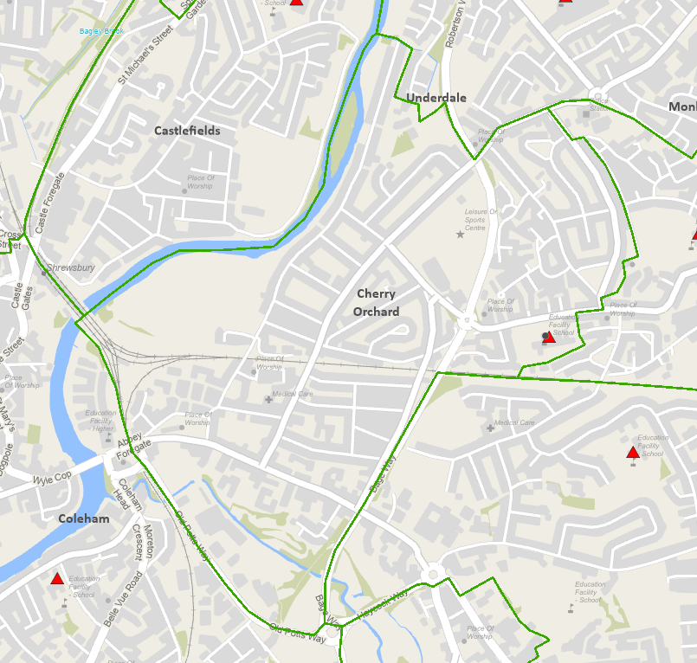
Crowmoor Primary School

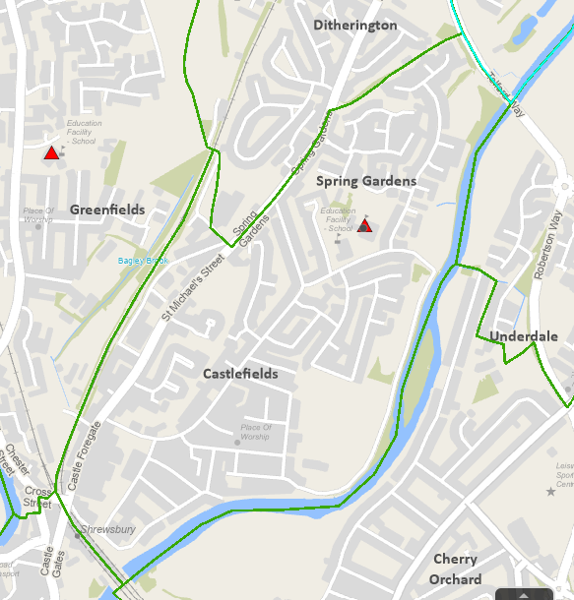
Martin Wilson School

