

Admissions Policy
2027-28

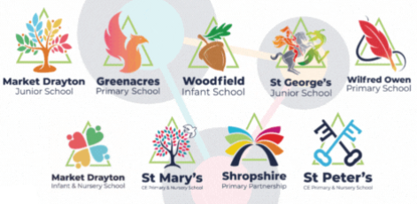

Admissions Policy
Empower Trust schools are academies and therefore Empower Multi Academy Trust are the admission authority and are therefore responsible for determining our admissions policy.

Admissions to Reception Year
For admissions to Reception Year application must be made through Shropshire Council by 15th January in the academic year prior to which your child is due to start school. All applications received by this date will be considered and parents will be informed by Shropshire Council on 16th April (or the next working day) if they have been allocated a place for their child.

Admissions to Year 3 at Junior Schools
For admissions to Year 3, application must be made through Shropshire Council by 15th January in the academic year prior to which your child is due to start school. All applications received by this date will be considered and parents will be informed by Shropshire Council on 16th April (or the next working day) if they have been allocated a place for their child.

Applicants in other parts of England should apply through their home local authority for Reception and junior places. Please see the Parents Guide to Education booklet on the website www.shropshire.gov.uk/schooladmissions for further details of the admission arrangements.

Admissions Criteria

Published Admission Number (PAN)
The published admissions number is the number of places available in each year group is determined by the capacity of the school

The Published Admissions Number for our schools are as follows:
Greenacres Primary School - 15
St Mary’s CE Primary School Shawbury – 38
St Peter’s CE Primary School, Wem – 60
The Wilfred Owen School – 30
Market Drayton Infant School and Nursery - 90
Market Drayton Junior School - 90
Woodfield Infant School and Nursery - 90
St George’s Junior School - 90
Empower Multi Academy Trust Primary Schools oversubscription criteria – Greenacres Primary School, St Mary’s CE Primary School, St Peter’s CE Primary School, The Wilfred Owen School

Children with an Education and Health Care Plan which names a Trust school will be allocated places, after which places are allocated up to the Published Admission Number of the Trust school according to an agreed set of criteria in strict order of priority as shown below.

Priority 1
Looked after children and children who were previously looked after but immediately after being looked after became subject to adoption, a child arrangements order, or special guardianship order (1), including those who appear to the admission authority to have been in state care outside of England and ceased to be in state care as a result of being adopted.

Priority 2
Children living within the catchment area who will have a sibling at the school on the day they are due to start school.

Priority 3
Children of staff members who have been continuously employed at the school, on a permanent contract, for at least two years at the time of application.

Priority 4
All other children who live within the catchment area.

Priority 5
Children living outside the catchment area who will have a sibling at the school on the day they are due to start school.

Priority 6
Al other children who live outside the catchment area.

Empower Multi Academy Trust Infant Schools oversubscription criteria – Market Drayton Infant School and Woodfield Infant School

Children with an Education and Health Care Plan which names a Trust school will be allocated places, after which places are allocated up to the Published Admission Number of the Trust school according to an agreed set of criteria in strict order of priority as shown below.

Priority 1
Looked after children and children who were previously looked after but immediately after being looked after became subject to adoption, a child arrangements order, or special guardianship order (1), including those who appear to the admission authority to have been in state care outside of England and ceased to be in state care as a result of being adopted.

Priority 2
Children living within the catchment area who will have a sibling at the school on the day they are due to start school.

Priority 3
Children living within the catchment area who will have a sibling at the linked junior school on the day they are due to start school.

Priority 4
Children of staff members who have been continuously employed at the school, on a permanent contract, for at least two years at the time of application.

Priority 5
Al other children who live within the catchment area.

Priority 6
Children living outside the catchment area who will have a sibling at the school on the day they are due to start school.

Priority 7
Children living outside the catchment area who will have a sibling at the linked junior school on the day they are due to start school.

Priority 7
Al other children who live outside the catchment area.

Market Drayton Infant School is linked with Market Drayton Junior School. Woodfield Infant School is linked with St George’s Junior School

Empower Multi Academy Trust Junior Schools oversubscription criteria – Market Drayton Junior School and St George’s Junior School

Children with an Education and Health Care Plan which names a Trust school will be allocated places, after which places are allocated up to the Published Admission Number of the Trust school according to an agreed set of criteria in strict order of priority as shown below.

Priority 1
Looked after children and children who were previously looked after but immediately after being looked after became subject to adoption, a child arrangements order, or special guardianship order (1), including those who appear to the admission authority to have been in state care outside of England and ceased to be in state care as a result of being adopted.

Priority 2
Children who have attended the linked infant school in Year 2 at the point of application to transfer to Year 3

Priority 3
Children living within the catchment area who will have a sibling at the school on the day they are due to start school.

Priority 3
Children living within the catchment area who will have a sibling at the linked infant school on the day they are due to start school.

Priority 4
Children of staff members who have been continuously employed at the school, on a permanent contract, for at least two years at the time of application.

Priority 5
Al other children who live within the catchment area.

Priority 6
Children living outside the catchment area who will have a sibling at the school on the day they are due to start school.

Priority 7
Children living outside the catchment area who will have a sibling at the linked infant school on the day they are due to start school.

Priority 7
Al other children who live outside the catchment area.

Market Drayton Infant School is linked with Market Drayton Junior School. Woodfield Infant School is linked with St George’s Junior School
Notes

If, in any of the above categories, there are more applications than there are places available, priority will begiven on the basis of distance measured as a straight line on a computerised mapping system between the home address and the nearest appropriate entrance gate of the school by pinpointing their eastings and northings. The shortest distance will be given priority. Where two addresses are within the same block of flats, the lowest number of flat or nearest the ground floor will be deemed to be the nearest in distance. In the event that two applications are exactly the same after all other criteria have been taken into account a tie breaker will be used. This will be by random allocation and overseen by an independent party not connected with the admissions process.

A looked after child is a child who is (a) in the care of a local authority, or (b) being provided with accommodation by a local authority in the exercise of their social services functions (see the definition in Section 22(1) of the Children Act 1989).
An adoption order is an order under the Adoption Act 1976 (see Section 12 adoption orders) and children who were adopted under the Adoption and Children Act 2002 (see Section 46 adoption orders).

A ‘child arrangements order’ is an order settling the arrangements to be made as to the person with whom the child is to live under Section 8 of the Children Act 1989 as amended by Section 14 of the Children and Families Act 2014.
Section 14A of the Children Act 1989 defines a ‘special guardianship order’ as an order appointing one or more individuals to be a child’s special guardian (or special guardians).

A sibling connection is defined as a brother or sister, stepbrother or stepsister, half-brother, or half-sister, living at the same address as part of the same family unit and of compulsory school age (i.e., 5 – 16 years). Fostered and adopted siblings are also included. Siblings must be attending the school on the date the sibling is due to start there. However, cousins or other relatives who assume residence in a home in order to establish an ‘in catchment area’ address will not be given priority under the sibling criterion.

Market Drayton Infant School is linked with Market Drayton Junior School. Woodfield Infant School is linked with St Georges Junior School

For phased transfers (the start of Reception or year 3 for Junior school) application for places for children moving into Shropshire Council’s area from another English local authority’s area can only be considered when formal confirmation (e.g., signed tenancy agreement when no property is owned, or exchange of contracts) of the address has been received.

All applicants are required to give correct information about the genuine residential address of the child. Where any information regarding a home address is found to be fraudulent or misleading a school place may be withdrawn even if the child has been admitted to the school. Where changes of address occur after application, an offer of a place may also be withdrawn if it is made on the basis of residence at a former address and the applicant has not advised the Admissions Team of a change of circumstances.

Catchment Maps
Catchment area maps for Empower Multi Academy schools can be found as appendix at the end of this policy. Alternatively can be viewed on the General Map viewer available from 'Maps' at the foot of the website www.shropshire.gov.uk or, in case of doubt, individual addresses can be checked by contacting the Admissions Team at Shropshire Council.
Waiting Lists

Admissions to our schools are managed by Shropshire Council who will hold any and all waiting lists. The waiting lists for all year groups are held and maintained on the school’s behalf by Shropshire Council for the academic year. The waiting list are held in strict accordance with our published oversubscription criteria and reranked after each additional child is added to the waiting list.

Should a vacancy become available the highest ranked application held in accordance with the published oversubscription criteria will be offered a place at the school by Shropshire Council on behalf of the school.

Mid-term or In-Year applications

Mid-term applications will be dealt with using the same admissions criteria given above. Applications must be made via the Shropshire Council online portal (Synergy - Homepage (shropshire.gov.uk) If there is a space in the relevant year group a place will be offered. A formal letter from Shropshire Council’s Admissions Team will be sent to the parent advising them of the offer and the need to contact school directly to arrange a start date.

If there are no vacancies in the year group, Shropshire Council’s Admission Team will speak to the Headteacher to consider whether additional places can be offered. If a place cannot be offered, parents will receive a formal letter and information on how to appeal against the decision from Shropshire Council’s School Admissions Team.

A decision must be notified to parents within 15 days of making the application
Shropshire Council will maintain a waiting list for unsuccessful applicants. If any vacancies arise, places will be offered to applicants included on the waiting list in strict accordance with normal published oversubscription criteria.

If a place can be offered the applicant will be expected to take up the place within 6 school weeks or by the start of the next half term, whichever is the earliest date, with the exception of Reception children who have deferred entry until later in the same academic year. If an offer of a place is refused, the name will be removed from the waiting list.

Applications for children to attend out of cohort

Children outside their normal age group
Parents may seek a place for their child outside of their normal age group, for example, if the child is gifted and talented or has experienced problems such as ill health. Admission authorities must make decisions based on the circumstances of each case and in the best interests of the child concerned. If a request is refused, the child will still be considered for admission to their normal age group.
Children can attend primary education from the September following their fourth birthday. The law requires that children attend school from the prescribed day of or following their fifth birthday (the prescribed days are 31 December, 31 March and 31 August). Shropshire Council does not offer the option for a child to start primary school before they are eligible.

The process for requesting such admissions is as follows;
With the application, parents should request that the child is admitted to another year group (state which one), and the reasons for that request. Parents will need to submit any evidence in support of their case with the application, for instance from a medical practitioner, headteacher etc. Some of the evidence a parent might submit could include:
    - information about the child’s academic, social and emotional development;
    - where relevant, their medical history and the views of a medical professional;
    - whether they have previously been educated out of their normal age group; and
    - whether they may naturally have fallen into a lower age group if it were not for being born prematurely.
Requests for admission out of the normal year group will be considered alongside other applications made at the same time.

Deferred Entry

Most children do start school in the September after they turn four. However, a child doesn't need to start school until they reach compulsory school age.

Summer-born children
Children born from 1 April to 31 August are known as summer-born children. They don't need to start school until the September after their fifth birthday, a year after they could first have started school. This is when summer born children reach compulsory school age.
Parents of summer-born children have two options if they feel their child isn't ready to start reception in September with their natural cohort:

Option 1 - delayed start
A parent of a summer-born child starting school aged 4 can, if they wish, agree with the allocated school a pattern of part-time attendance or a deferred start until later in that school year (but not later than the beginning of the summer term). You can discuss this with the school.

This will require the parent to apply on time (by 15 January) using the application process provided by your local authority. Once places are allocated on the 16 April the parent can contact the headteacher to discuss the delayed start.

Option 2 - defer for a full year
If a parent decides that their summer-born child will start school aged five and wants that child to start school in reception (not year 1), they need to make a request to the local admission authority. This is called requesting admission out of the normal age group – because children born from 1 September in one year to 31 August the following year are normally educated together in one year group.

This means that you'll need to decide whether or not you want to request admission out of the normal age group in the autumn following your child’s third birthday. Remember that your child will do lots of growing and developing before they reach the point at which they could start school.

This information doesn't apply to children with education, health and care (EHC) plans. If your child has an EHC plan and you wish them to start school in reception (not year 1) when they're five, you should contact the SEN team. Having special educational needs and disabilities (SEND) doesn't necessarily mean a child should delay starting school. It may be better for them to start school before compulsory school age so that they can access the support available there.

If you decide that you want to defer for a full year
You should still apply for a school place as normal by 15 January – as if your child was going to start school at age four – even if you want to delay their start until age five.

You should also submit a request for admission out of the normal age group ideally by 15 January. Shropshire residents can email school-admissions@shropshire.gov.uk to request this. The admission authority decides whether children who start school at compulsory school age should be admitted to reception or year 1. They must make this decision in the child’s best interests.
If you decide to delay your child starting school until the September following their fifth birthday but don't request admission out of their normal age group at this time, your child will start school in year 1. You'll need to make an in-year application for a school place for your child, and we can advise you on when it would be best to make such an application. Please note that some schools are likely to be full at this point and unable to offer you a place. Schools are unable to hold a place for your child from the previous year.
Please be advised that should a summer-born child defer for a year, it's currently a requirement to make another request to defer their entry to the next phase of their education. When a child of year 6 age is being taught in year 5, an application for secondary school and a request to defer their entry to secondary school will need to be made. Another point to be aware of is a summer-born child deferred for a year will reach school leaving age at the end of year 10, rather than year 11. The school won't ask them to leave, but they'll no longer be required by law to attend school, and the school may not be able to enforce their attendance. Children usually take their GCSEs in year 11.

Please visit the Gov.UK website for further information on summer-born children starting school.

Appeals

All applicants refused a place have a right of appeal to an independent appeal panel constituted and operated in accordance with the School Admission Appeals Code. Empower Multi Academy Trust has delegated the coordination of the appeals to the Admissions Team at Shropshire Council.

Appellants should contact Shropshire Council School Admissions Team for information on how to appeal. Information on the timetable for the appeals process is on the website www.shropshire.gov.uk/schooladmissions. Parents must be given at least 20 school days from the date of notification that their application was unsuccessful to lodge an appeal.

Children of Service Personnel
Empower Multi Academy Trust schools will consider service personnel applicants in line with the Armed Covenant to ensure they are not disadvantaged.

Appendix Catchment Maps

Greenacres Primary School Catchment Area Map
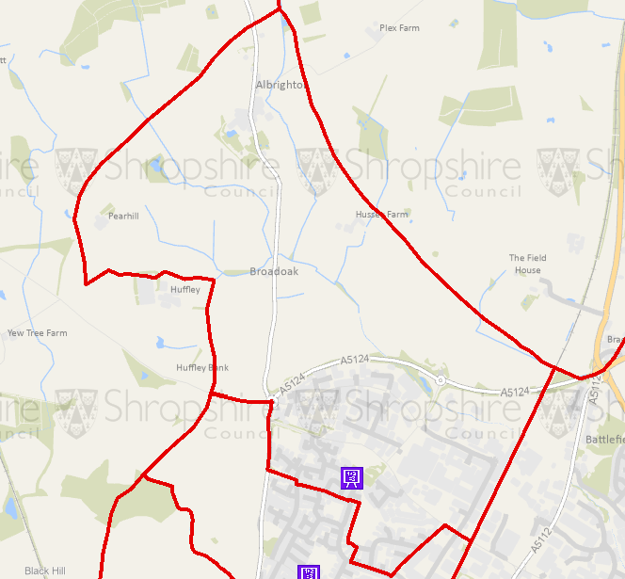

Woodfield Infant School and St Georges Junior School Catchment Area Map

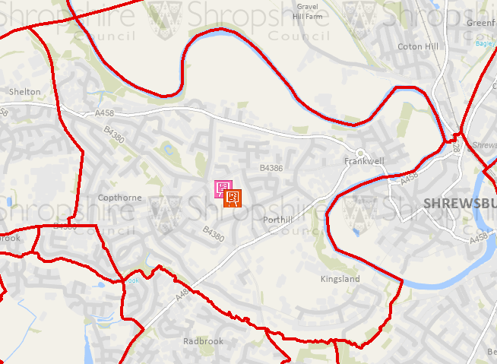

Wilfred Owen Primary School Catchment Area Map
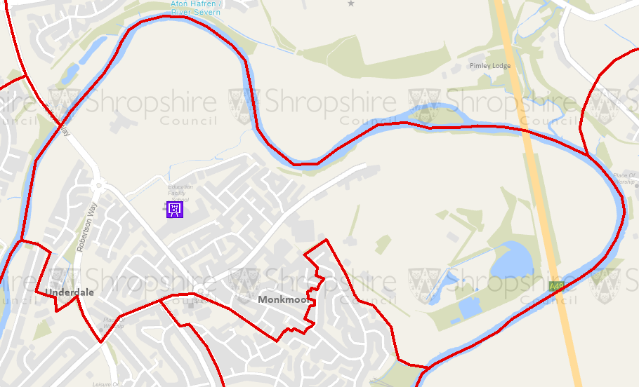

Market Drayton Infant and Market Drayton Junior School Catchment Area Map
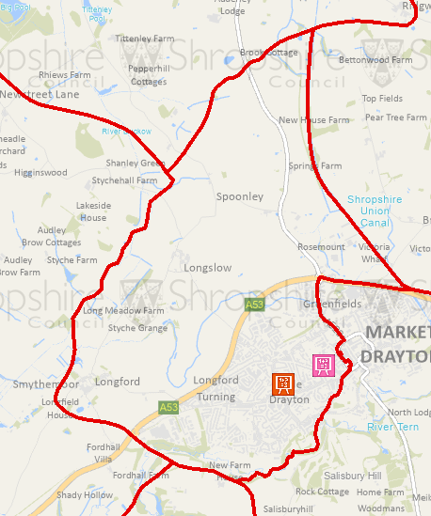

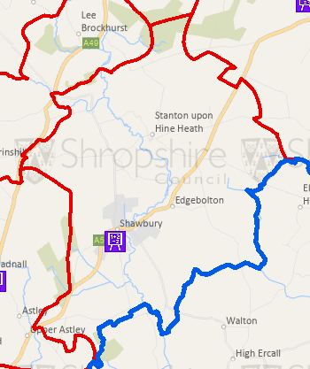
St Mary’s CE Primary School, Shawbury Catchment Area Map

St Peter’s CE Primary School, Wem Catchment Area Map
