

Admissions Policy
2027-2028

Autumn Term 2025

PUPIL ADMISSIONS

Pupils will be admitted at the age of eleven without reference to ability or aptitude. The Corbet School has an admission figure of 135, which was consulted on in November 2025. There is no cost associated with the admissions process to the Corbet School, which follows the Shropshire Local Authority Guidelines.

All parents of admitted pupils will be requested to confirm that they have read and understood the Handbook to Parents and Pupils.

OVER-SUBSCRIPTION

The Trustee Board’s Admissions Committee will discharge the functions conferred on it by The Education (School Government) (England) Regulations 1999. Where applications for admission exceed the number of places available, the Admissions Committee will apply the following criteria, in the order of priority set out below, to decide which children to admit.** Children with an Education and Health Care Plan (EHCP) which names The Corbet School will be allocated places, after which places will be allocated according to the agreed set of criteria in strict order of priority.

PRIORITY

- Looked after children or children who were previously ‘looked after’ but immediately after being looked after became subject to an adoption, child arrangements, or special guardianship order¹ including those who appear [to the admission authority (The Corbet School)] to have been in state care outside of England and ceased to be in state care as a result of being adopted.
.
- Children living within the attendance area, (as defined by Shropshire Council Local Authority), with a sibling at The Corbet School. A sibling connection is defined as a brother or sister, step-brother or step-sister, half-brother or half-sister, living at the same address as part of the same family unit and of compulsory school age (i.e. 5 – 16 years). Fostered and adopted siblings are also included. Older siblings must be attending the school on the date the younger sibling is due to start there. However, cousins or other relatives who take up residence in home in order to establish an “in attendance area” address will not be given priority under the sibling criterion.

- Other children living inside the attendance area.

- Children living outside the attendance area with a sibling connection, (see Priority 2 above).

- Children outside the attendance area without a sibling connection, (see Priority 2 above), at The Corbet School, but who have attended a maintained primary school that lies within The Corbet School’s attendance area for more than a whole academic year immediately prior to transfer.

- Children of staff at the school.
  - Where the member of staff has been employed at the school for two or more years at the time at which the application for admission to the school is made, and / or
  - The member of staff is recruited to fill a vacant post for which there is a demonstrable skill shortage.

- Children living outside the attendance area.
Where the admission number is reached and a decision has to be made to differentiate between children who fall into the same criteria groupings of Priorities 1 - 6 above, priority will be given to those children who live nearest to the school. For admissions purposes all distances are measured as a straight line distance on a computerised mapping system between the home address and the nearest entrance gate of the relevant school by pinpointing their eastings and northings. The shortest distance being given highest priority. Where two addresses are within the same block of flats, the lowest number of flat nearest to the ground floor will be deemed to be the nearest in distance.

In the case of twins or triplets from the same address the school will endeavour to admit both or all siblings. In the event that two individual applications are exactly the same after all other criteria have been taken into account, a tie breaker will be used. This will be by random allocation and overseen by an independent party not connected with the admissions process.

Notes:

**In very exceptional circumstances the following criterion may apply and such children may be allocated a higher priority above Priorities 2 to 6.

Where a child has particular health reasons for wishing to attend The Corbet School. Such cases will only be given priority if medical evidence can be provided which demonstrates that attending Corbet School is essential to the medical well-being of the child. The Trustee Board reserves the right to check the essential nature of the medical condition with the relevant medical practitioner.

Admissions to Attend out of Cohort: parents may seek a place for their child outside of their normal age group, for example, if the child is gifted and talented or has experienced problems such as ill health. Admission authorities must make decisions based on the circumstances of each case and in the best interests of the child concerned. If a request is refused.

The process for requesting such admissions is as follows;
With the application, parents should request that the child is admitted to another year group (state which one), and the reasons for that request. Parents will need to submit any evidence in support of their case with the application, for instance from a medical practitioner, headteacher etc. Some of the evidence a parent might submit could include:

- information about the child’s academic, social and emotional development;
- where relevant, their medical history and the views of a medical professional;
- whether they have previously been educated out of their normal age group; and
- whether they may naturally have fallen into a lower age group if it were not for being born prematurely.

Requests for admission out of the normal year group will be considered alongside other applications made at the same time.

APPLICATIONS

Admissions to The Corbet School for all Year 7 September Intakes will be via Shropshire Council’s online admission facility. This will be available from September in the application year. Parents unable to apply online should contact the Council’s Admissions Team via email school-admsisions@shropshire.gov.uk or via post c/o The Guildhall, Frankwell Quay, Shrewsbury, SY3 8HQ. Applications will be required by 31st October via www.Shropshire.gov.uk The School’s Admissions Committee will then consider all applications made to this school via the Council and will inform the Council’s Admissions Team of the places to be allocated. The Council will inform parents on behalf of the school of its decision by post on 1st March, or the nearest school day that particular year. This will be a common date for secondary allocations across the country. Parents will only be offered one school place for each child. Therefore, if The Corbet School is not able to offer a place, the Council will inform parents/guardians of a place at another school which they can offer to the child. Parents are advised that it is in their child’s best interest to ensure that they have given more than one preference on their application form.

It is important that applicants are aware that: where a year group already meets or exceeds the school’s published standard number of 135 it would not normally expect to admit further pupils. This is because the Trustee Board’s Admission Committee have always felt that the admission of more pupils would lead to overcrowding and large classes in some teaching sets and would jeopardise the ability of the school to provide effective teaching to all of its pupils. Additional admissions to The Corbet School would thus prejudice the effective use of resources.

Late Applications: Parents are asked to note that the closing date for applications is 31st October. Any applications received after this date will not be considered until after all other allocations have been made unless there are exceptional circumstances, e.g. a family has just moved house into the area or a family difficulty such as a serious illness
or bereavement. In such circumstances the school and Shropshire Council will endeavour to include the application up until the first week in February. Otherwise late applicants will be placed on a waiting list.

In-Year Admissions

From 1 September 2024. Shropshire Council will be coordinating and allocating all requests for places at our school.

We welcome prospective parents to visit our school. If you wish to apply for a place at our school, please complete the online application form via this link – Synergy - Homepage (shropshire.gov.uk)

Your application will be processed by the School Admissions Team at Shropshire Council in accordance with our school’s oversubscription criteria. You will then be notified via letter of the outcome of your application.

APPEALS

The Trustee Board has established arrangements for appeals against non-admission, which include an independent element.

Where a child is refused admission by the school’s Admissions Committee, the Trustee Board will ensure that the parents are informed of their right of appeal. The Schol has arranged for Shropshire Council to administer admissions appeals on its behalf. Parents/carers wishing to appeal should do so via the Shropshire Council Website www.shropshire.gov.uk/schooladmissions Parents must be given at least 10 school days from the date of notification that their application was unsuccessful to lodge an appeal.

Any child who cannot be offered a place at The Corbet school will automatically be added to the waiting list for all year groups, which Shropshire Council coordinate on our behalf. . Should a vacancy become available the highest ranked application held in accordance with the published oversubscription criteria will be offered a place at the school by Shropshire Council on behalf of the school. Our waiting list is re-ranked each time a new application is added to our waiting list.

Fair Access: The academy participates in the Local Authority Fair Access Protocol (“FAP”); this covers children that fall in to prescribed categories of vulnerable and/ or hard to place children, where they are having difficulty in securing a school place in-year AND it can be demonstrated that reasonable measures have been taken to secure a place through the usual in-year admission procedures. As this is a separate admissions process required by the School Admissions Code and administered by the Local Authority, where a place has been allocated under the FAP such admissions are made without reference to those on the waiting list and may necessarily take priority over them.

Catchment map:

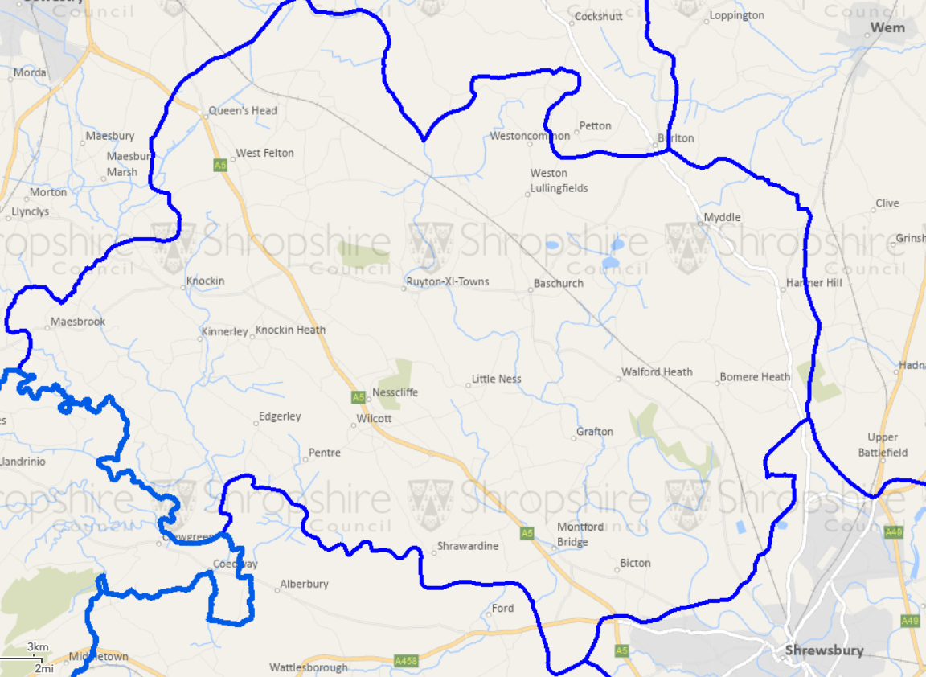

The link to the online mapping software – the link for your ease is General Map Viewer

