

ADMISSIONS POLICY: 2027/2028

The Trust and the Academy have made every effort to ensure that these arrangements comply with the Schools Admissions Code 2021 and all relevant legislation.

Shropshire Church of England Academies Trust acts as the Academy’s admission authority and determines its own admission arrangements in line with the Funding Agreement with the Secretary of State.

The Trust has devolved the responsibility for the coordination and processing of any and all applications for places at each of its schools to Shropshire Council. However, Shropshire Church of England Academies Trust makes all decisions regarding admissions of children to their schools.

Presented & Approved by Trust Board
Signed by Chair of Trust Board
Name of Chair of Trust Board | Malcolm Maclean
Version | 1.0
Date of Next Review | October 2026 or sooner if changes to legislation occur.

Applications to School

Shropshire Church of England Academies Trust schools are academy schools and therefore
Shropshire Church of England Academies Trust are responsible for their own admission arrangements but in order to help everyone, we follow the same timescale as the rest of Shropshire LA.

Shropshire Church of England Academies Trust consists of the following schools
Beckbury CE Primary School
Bicton CE Primary
Bomere Heath CE Primary
Christ Church CE Primary, Cressage
Meole Brace CE Primary and Nursery
St John the Baptist CE Primary, Ruyton
St Mary's Bluecoat CE Primary School, Bridgnorth
Worfield Endowed CE Primary School

Many parents choose to let us know at an early date that they would like their child to attend the school in due course. A preliminary form stating this interest can be obtained from school. Whilst it is helpful if parents can let us know at this early stage, it must be noted that such expressions of interest do not constitute registering a child or placing a child’s name on a waiting list nor being offered a place. Offers of places can only be confirmed in the academic year before the child is due to start school after application has been made to Shropshire Council via the online application facility. This should be made before the closing date of 15th January preceding the academic year in which the child is due to start school.

Parents can name up to 4 preferences in their application. Anyone unable to access the online facility should contact the Admissions Team. The Admissions Committee is responsible for the allocation of places. Parents will be informed by letter from the Council’s Admissions Team on behalf of the governing body whether their application has been successful or not after 16th April.

Parents who are interested in sending their child to the school are welcome to make an initial visit to the school. Information about the school is provided on the school’s website

At what age may your child start school?

Children can attend primary education from the September following their fourth birthday. The law requires that children attend school from the prescribed day of or following their fifth birthday (the prescribed days are 31 December, 31 March and 31 August). Most children do start school in the September after they turn four. However, a child doesn't need to start school until they reach compulsory school age, and a delayed start date will need to be discussed and agreed with the headteacher.

Shropshire Church of England Academy Trust and Shropshire Council does not offer the option for a child to start primary school before they are eligible.

Summer-born children
Children born from 1 April to 31 August are known as summer-born children. They don't need to start school until the September after their fifth birthday, a year after they could first have started school. This is when summer born children reach compulsory school age.
Parents of summer-born children have two options if they feel their child isn't ready to start reception in September with their natural cohort:

Option 1 - delayed start
A parent of a summer-born child starting school aged 4 can, if they wish, agree with the allocated school a pattern of part-time attendance or a deferred start until later in that school year (but not later than the beginning of the summer term). You can discuss this with the headteacher.
This will require the parent to apply on time (by 15 January) using the application process provided by your local authority. Once places are allocated on the 16 April the parent can contact the headteacher to discuss the delayed start.

Option 2 - defer for a full year
If a parent decides that their summer-born child will start school aged five and wants that child to start school in reception (not year 1), they need to make a request to the local admission authority. This is called requesting admission out of the normal age group – because children born from 1 September in one year to 31 August the following year are normally educated together in one year group.
This means that you'll need to decide whether or not you want to request admission out of the normal age group in the autumn following your child’s third birthday. Remember that your child will do lots of growing and developing before they reach the point at which they could start school.
This information doesn't apply to children with education, health and care (EHC) plans. If your child has an EHC plan and you wish them to start school in reception (not year 1) when they're five, you should contact the SEN team. Having special educational needs and disabilities (SEND) doesn't necessarily mean a child should delay starting school. It may be better for them to start school before compulsory school age so that they can access the support available there.

If you decide that you want to defer for a full year, you should still apply for a school place as normal by 15 January – as if your child was going to start school at age four – even if you want to delay their start until age five.
You should also submit a request for admission out of the normal age group ideally by 15 January. Shropshire residents can email schooladmissions@shropshire.gov.uk to request this.
The admission authority decides whether children who start school at compulsory school age should be admitted to reception or year 1. They must make this decision in the child’s best interests.
If you decide to delay your child starting school until the September following their fifth birthday but don't request admission out of their normal age group at this time, your child will start school in year 1. You'll need to make an in-year application for a school place for your child., Schools are unable to hold a place for your child from the previous year.
The allocation date for 2027/28 will be 16th April 2027.

Applying for a place out of cohort

Parents may seek a place for their child outside of their normal age group, for example, if the child is gifted and talented or has experienced problems such as ill health. Admission authorities must make decisions based on the circumstances of each case and in the best interests of the child concerned. If a request is refused, the child will still be considered for admission to their normal age group.

The process for requesting such an admission outside the normal age group, is as follows. With the application, parents should request that the child is admitted to another year group (state which one), and the reasons for that request. Parents will need to submit any evidence in support of their case with the application, for instance from a medical practitioner, headteacher etc. Some of the evidence a parent might submit could include:

- information about the child’s academic, social and emotional development;
- where relevant, their medical history and the views of a medical professional;
- whether they have previously been educated out of their normal age group; and
- whether they may naturally have fallen into a lower age group if it were not for being born prematurely.

With the application, parents should request that the child is admitted to another year group (state which one), and the reasons for that request. Further evidence may be requested. Requests for admission outside of the normal year group will be considered alongside other applications made at the same time.

Admissions Criteria

All our schools are Church of England Primary Schools and Christian values underpin our ethos, but we welcome children of all faiths or those of no faith. We sometimes have space to take children from outside of our catchment and are happy to show families around the school by appointment.

Published Admissions Number (PAN)
The published admissions number is the number of places available in each year group is determined by the capacity of the school

Beckbury CE Primary School - 8
Bicton CE Primary - 21
Bomere Heath CE Primary - 20
Christ Church CE Primary, Cressage - 15
Meole Brace CE Primary and Nursery - 60
St John the Baptist CE Primary, Ruyton - 20
St Mary's Bluecoat CE Primary School, Bridgnorth - 30
Worfield Endowed CE Primary School – 29

In implementing their admissions policy, the Trust board seeks to ensure that all admissions to the school are carried out fairly.

Children with a Statement of Special Educational Needs or Education and Health Care Plan (EHCP) which names one of our schools will be allocated places, after which places are allocated according to an agreed set of criteria in strict order of priority as follows:

- 'Looked after children' or children who were previously ‘looked after’ but immediately after being looked after became subject to an adoption, child arrangements, or special guardianship order¹ including those who appear to the admission authority, Shropshire Church of England Academies Trust, to have been in state care outside of England and ceased to be in state care as a result of being adopted.

- Children with medical or special circumstances. This will be considered only if parents can provide written medical evidence that the school (and no other) is essential to the medical wellbeing of their child. In exceptional circumstances priority may be given above those children who qualify under priorities 3 to 8.

- Children living in the designated catchment area (see appendix 1) and who have a sibling at the school on the date they are due to start.

- Other children living inside the designated catchment area (see appendix 1) and whose homes are nearest to the school.

5 Children of staff at the school in either or both of the following
circumstances
5a. Where the member of staff has been employed at the school for two or
more years at the time at which the application for admission to the school
is made; and/or.
5b. the member of staff is recruited to fill a vacant post at the school for
which there is a demonstrable skill shortage.

- Children living outside the catchment area and who have a sibling at the school on the day they are due to start and whose homes are nearest to the school.

6. Other children living outside the catchment area on a distance basis

Notes:
A looked after child who is (a) in the care of the local authority or (b) being provided with
accommodation by a local authority in the exercise of their social services functions (see the
definition in Section 22(1) of the Children Act 1989)
¹ An adoption order is an order under the Adoption Act 1976 (see Section 12 adoption orders) and children who were adopted under the Adoption and Children Act 2002 (see Section 46 adoption orders).
A ‘child arrangements order’ is an order settling the arrangements to be made as to the person with whom the child is to live under Section 8 of the Children Act 1989 as amended by Section 14 of the Children and Families Act 2014.
Section 14A of the Children Act 1989 defines a ‘special guardianship order’ as an order
appointing one or more individuals to be a child’s special guardian (or special guardians)

A sibling connection is defined as a brother or sister, step-brother or step-sister, half-brother or half-sister, living at the same address as part of the same family unit and of compulsory school age (i.e. 5 – 16 years). Fostered and adopted siblings are also included. Siblings must be attending the school on the date the younger sibling is due to start there. However, cousins or other relatives who take up residence in a home in order to establish an “in catchment area” address will not be given priority under the sibling criterion.

For admissions purposes, all distances are measured as a straight-line distance on a computerised mapping system which pinpoints the eastings and northings of the home address and the nearest appropriate entrance gate of the relevant school. The shortest distance being given highest priority. Where two addresses are within the same block of flats, the lowest number of flat or nearest to the ground floor will be deemed to be the nearest in distance.

In the case where one of twins or triplets from the same address are successful in application, the school will admit both or all multiple siblings.

In the event that two or more applications are considered to be of equal priority after all other criteria have been taken into account a tie breaker will be used. This will be by random allocation and overseen by an independent party not connected with the admissions process.

There is no cost associated with the admissions process to any Shropshire LA maintained schools.

Late Applications

Applications received after 15 January will only be handled where a family has moved house after the closing date or where there has been a serious illness or bereavement in the family. In such exceptional cases the latest date by which applications can be considered by the deadline date published in the Parents’ Guide to Education in Shropshire booklet. Where a late application cannot be allocated a place the applicant’s name will be placed on a waiting list.

Unsuccessful Applications

Appeals- Arrangements for appeals panels

Shropshire Church of England Academies Trust is required to offer all pupils refused admission the right to an appeal in front of an independent appeals panel. Shropshire Church of England Academies Trust is responsible for setting up the appeal and must do so in accordance with the School Admission Appeals Code. The panel must be independent of the school. The Trust has arranged for Shropshire Council to administer admissions appeals on its behalf. Parents/carers wishing to appeal should do so via the Shropshire Council Website www.shropshire.gov.uk/schooladmissions Parents must be given at least 10 school days from the date of notification that their application was unsuccessful to lodge an appeal.

If the appeal is still unsuccessful the applicant’s name will be placed on a waiting list which will operate until the beginning of the new academic year. If, subsequently, a place comes available and there are 2 or more applicants the admissions criteria will be used to determine the priority of the applications.

Waiting Lists

Admissions to Shropshire Church of England Academies Trust schools are managed by the Local Authority, who will hold any waiting lists. The waiting lists for all year groups are held and maintained on the school’s behalf by Shropshire Council for the academic year. The waiting list are held in strict accordance with our published oversubscription criteria and reranked after each additional child is added to the waiting list.

Should a vacancy become available the highest ranked application held in accordance with the published oversubscription criteria will be offered a place at the school.

Fair Access

Shropshire Church of England Academies Trust schools participates in the Local Authority Fair Access Protocol (“FAP”); this covers children that fall in to prescribed categories of vulnerable and/ or hard-to-place children, where they are having difficulty in securing a school place in-year AND it can be demonstrated that reasonable measures have been taken to secure a place through the usual in-year admission procedures. As this is a separate admissions process required by the School Admissions Code and administered by the Local Authority, where a place has been allocated under the FAP such admissions are made without reference to those on the waiting list and may necessarily take priority over them.

In Year Admission Process (at times other than start of Reception)

Mid-term applications are made directly to Shropshire Council.
If a parent wishes to apply for a place(s) for their child(ren) at our school, they should complete the online application form via this link –
Synergy - Homepage (shropshire.gov.uk)

Application considered by LA against school’s admission policy criteria*/admission numbers

NO– parent advised. Refusal letter and appeal instructions provided.

YES –place offered to parents by Shropshire LA Admissions Team,

Local authority can provide alternative placement advice. Consideration given to Fair Access Protocol referral

* If a place is available within the PAN then a place will be offered by the Headteacher and it will be reported back to the LA & Trust.

Shropshire Council coordinate and allocate all requests for places at all our Shropshire Church of England Academies Trust schools.

If you wish to apply for a place at our school, please complete the online application form via this link – Synergy - Homepage (shropshire.gov.uk)

Your application will be processed by the School Admissions Team at Shropshire Council in accordance with our school’s oversubscription criteria. You will then be notified via letter of the outcome of your application.

Mid-term applications will be dealt with using the same admissions criteria given above.

If there is a space in the relevant year group a place will be granted. If the application is for a place in an over-subscribed year group, then the Headteacher will liaise with the Trust to consider whether additional places can be offered above the published admission number. If a place cannot be offered, parents will receive a formal letter and information on how to appeal against the decision from Shropshire Council Admissions Team.

In certain circumstances specified in admissions regulations, the school may be required to offer places to children over and above the published admission number due to their exceptional circumstances e.g. service children in accordance with the Armed Forces Covenant or children who are placed in accordance with the Fair Access Protocol.

The LA maintain a waiting list for all year groups for unsuccessful applicants. If any vacancies arise, places will be offered to applicants included on the waiting list in strict accordance with normal published oversubscription criteria. If a place can be offered the applicant will be expected to take up the place within 6 school weeks or by the start of the next half term, whichever is the earliest date, with the exception of Reception children who have deferred entry until later in the same academic year. If an offer of a place is refused, the pupils’ name will be removed from the waiting list.

Allocation of places for children moving into Shropshire Council’s designated catchment area can only be considered when formal confirmation (signed tenancy agreement when no property is owned, or exchange of contracts) of the address has been received.

All applicants are required to give correct information about the genuine residential address of the child. Where any information regarding a home address is found to be fraudulent or misleading a school place may be withdrawn even if the child has been admitted to the school.

Nursery
Shropshire Church of England Academies Trust school Nursery is not a guarantee or a condition of entry to the school.

Date of policy: October 2025

Catchment Maps
Catchment area maps for Shropshire Church of England Academies Trust schools can be found as appendix at the end of this policy. Alternatively can be viewed on the General Map viewer available from 'Maps' at the foot of the website www.shropshire.gov.uk or, in case of doubt, individual addresses can be checked by contacting the Admissions Team at Shropshire Council.

Beckbury CE Primary School Catchment Map

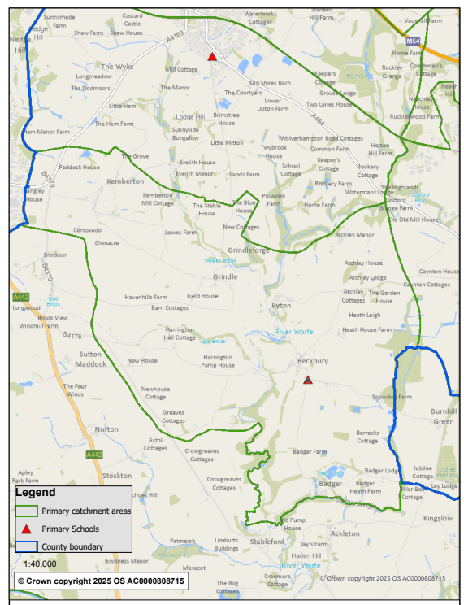
Beckbury CE Primary School

Bicton CE Primary Catchment Map

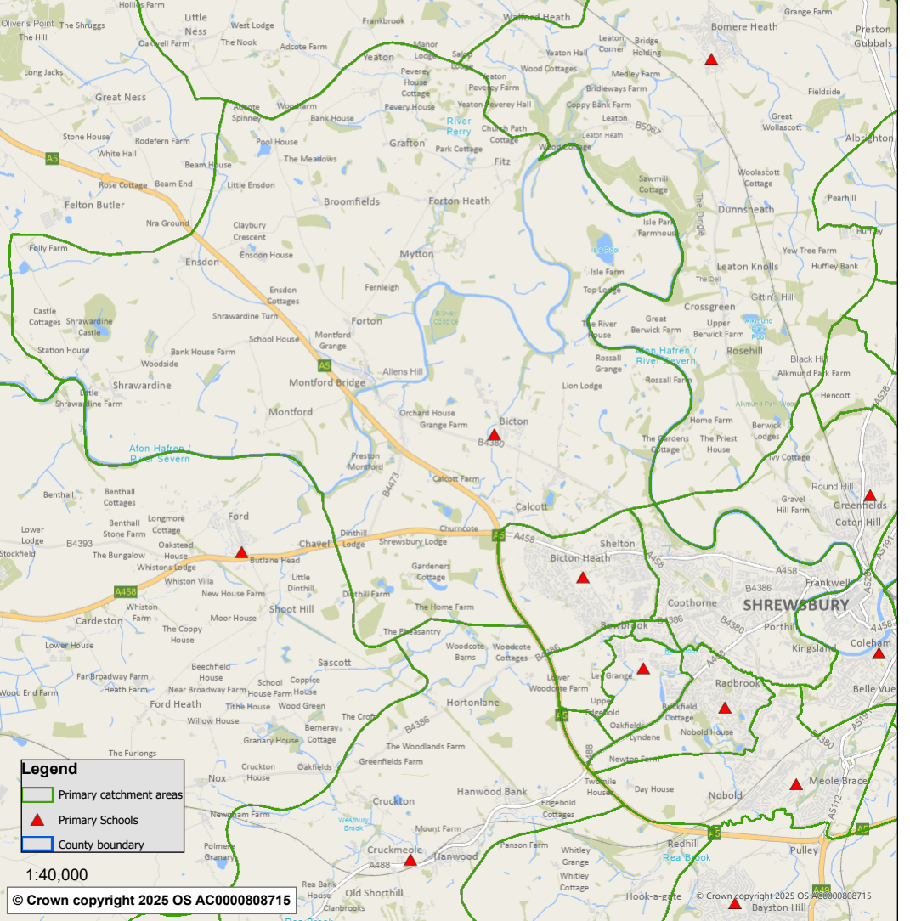
Bicton CE Primary School

Bomere Heath CE Primary Catchment Map

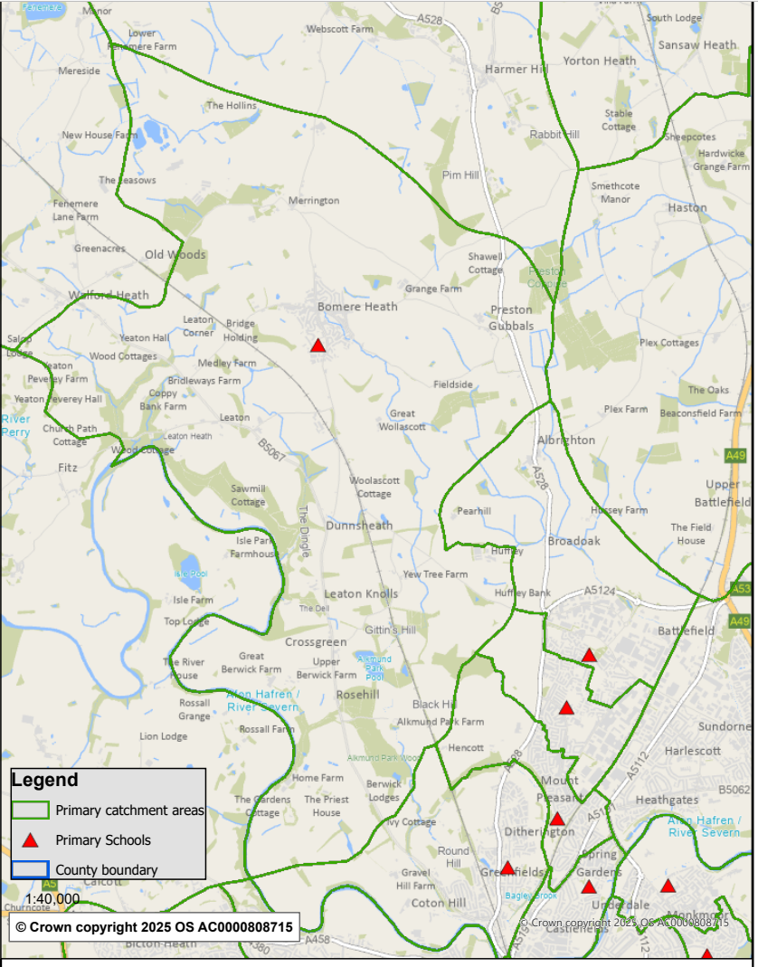
Bomere Heath CE Primary School

Christ Church CE Primary, Cressage Catchment Map

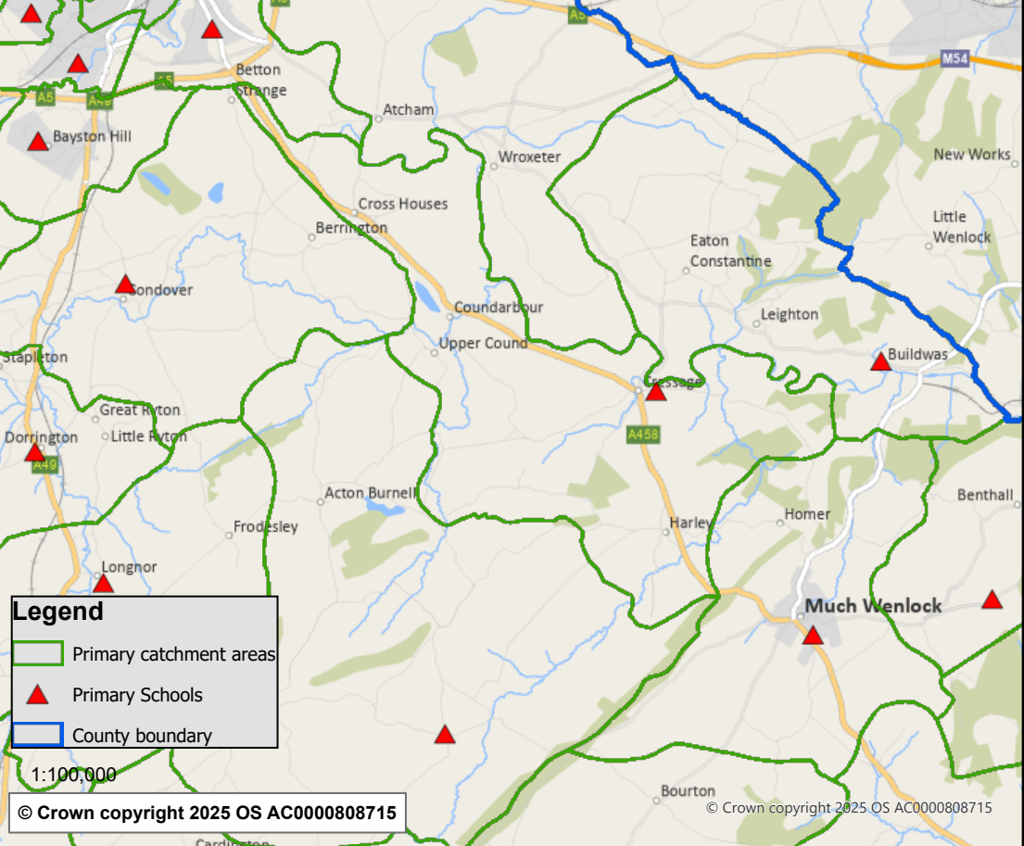
Christ Church CE Primary School

Meole Brace CE Primary and Nursery Catchment Map

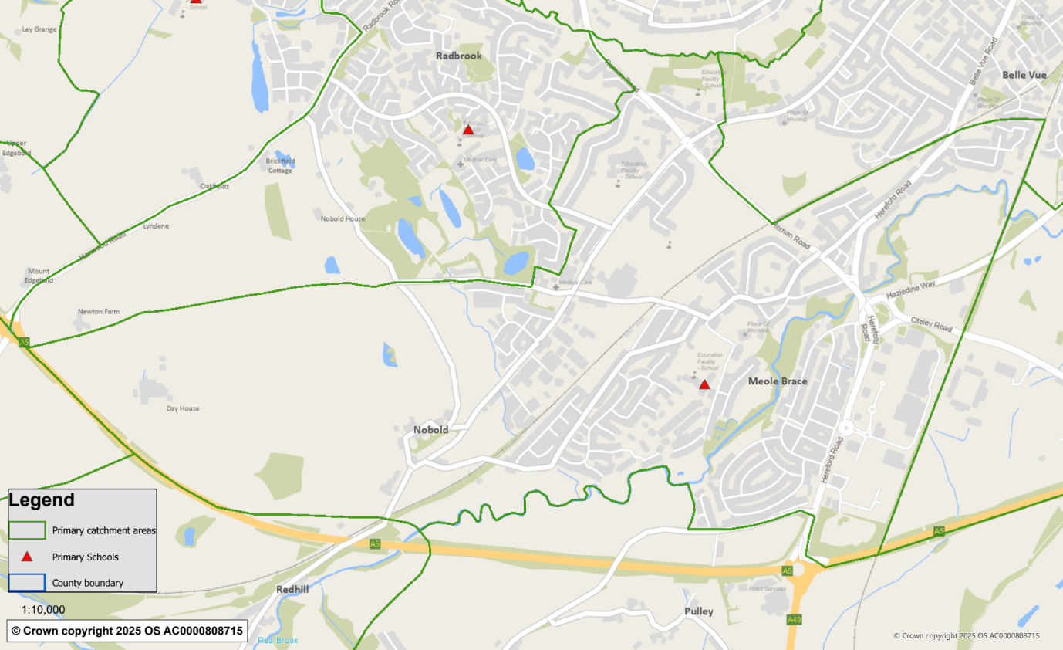
Meole Brace CE Primary School

St John the Baptist CE Primary, Ruyton Catchment Map

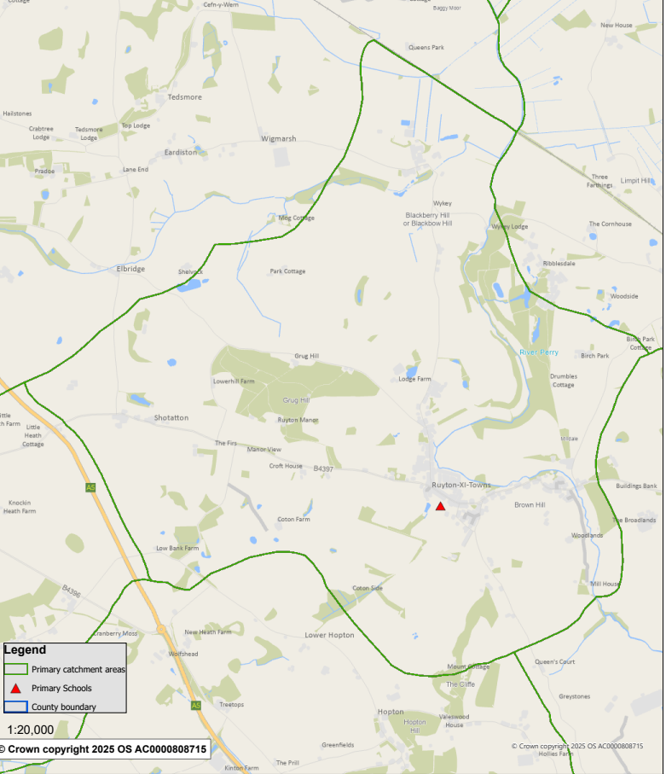
St John the Baptist CE Primary School

St Mary's Bluecoat CE Primary School, Bridgnorth Catchment Map

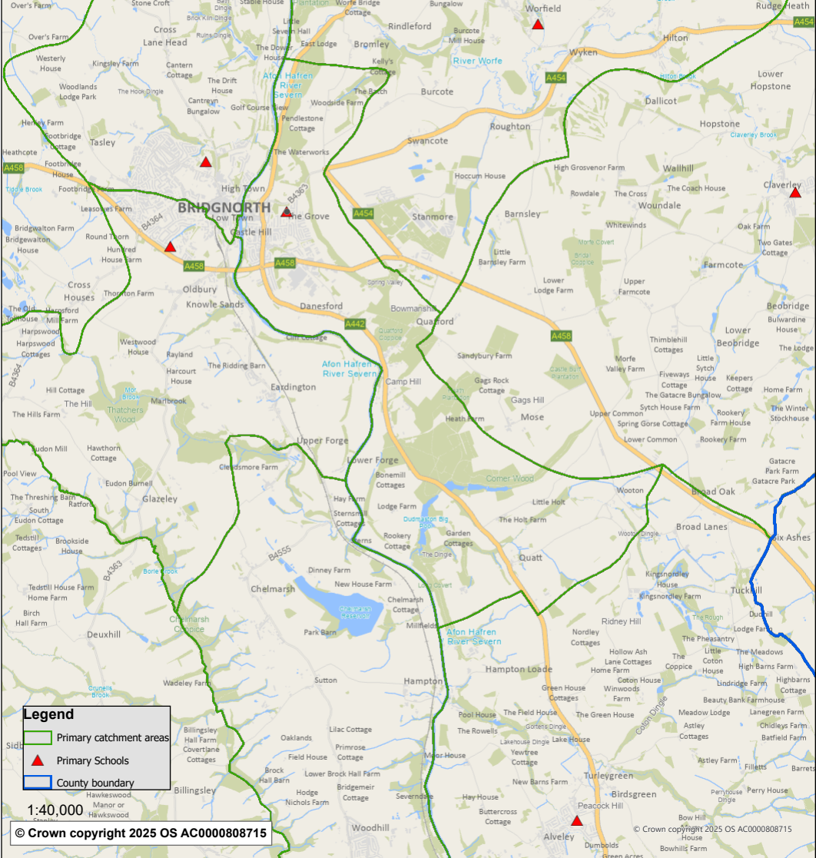
St Mary’s Bluecoat CE Primary School

Worfield Endowed CE Primary School Catchment Map

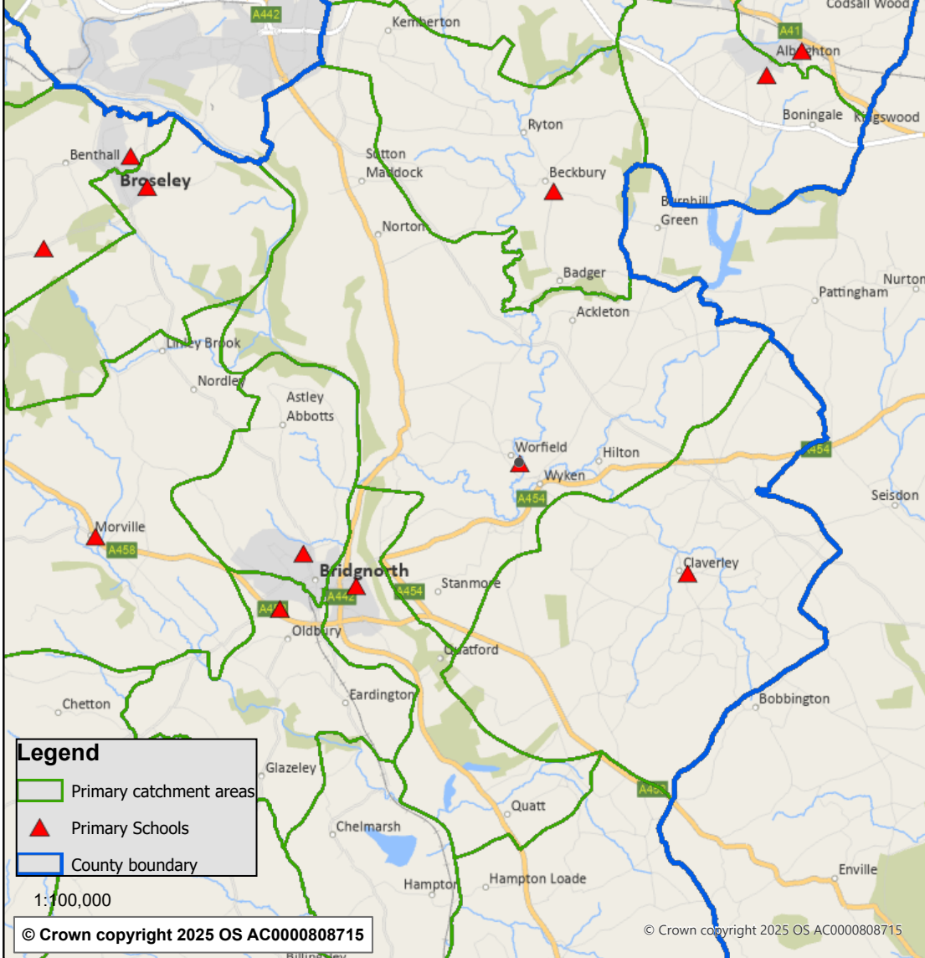
Worfield Endowed CE Primary School

