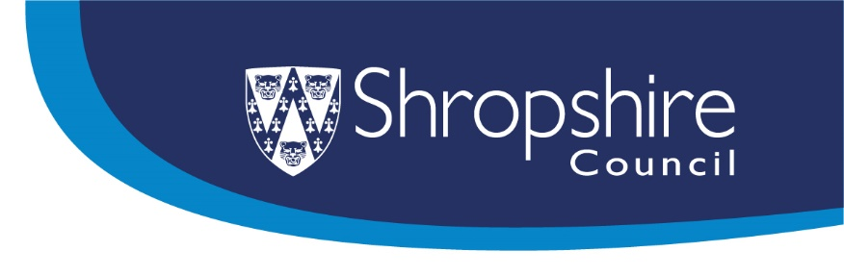

Shropshire Short Breaks Service

Parents/Carers –
We want to know what you want

May/June 2024


Introduction
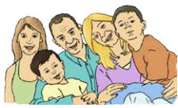 | Do you know?  Shropshire Short Breaks helps children and young people with special educational needs and disabilities (SEND) to have fun and take part in activities and give parents and carers a short break too.
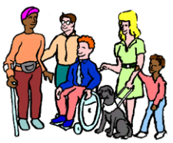 | We are asking children, young people, and their parent carers what they think about Short Breaks.
 | We want to know what kinds of activities and support that you would like from Short Breaks, whether you have used this service or not.
 | There are no right or wrong answers. We are just interested in what you think.  You can email us at tellus@shropshire.gov.uk if you need any help or have any other comments.
 | You can tell us what you think by  ticking the boxes on this form.  You have until the 12th of June 2024 to tell us what you think.

Our plans

 | We will use your comments to help us decide who should deliver the service from the start of 2025.

About You:

- Are you the parent carer of a child or young person with SEND?*

*If you have more than one child with SEND, please fill out one survey for each child.

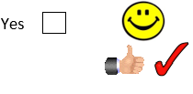
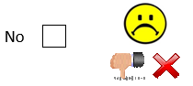
Please tick () 1 box

Please tick () whichever box describes your child or young person best

My child is 0-5 years old

My child is 6-10 years old

My child is 11-15 years old
My child is 16-18 years old

- Have you ever used Shropshire Short Breaks

Please tick () one box

If you answered “Yes”, please continue with Question 3 on the next page.

*If you answered “No” to question 2 please tell us in the box below why you have not used Short Breaks before.

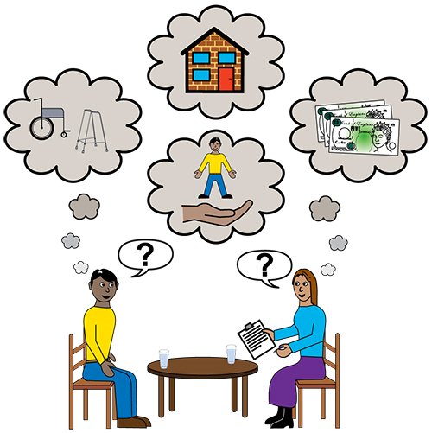

Thank you for telling us why you have not used Short Breaks before. You can now skip to page 7 to tell us a little more about what you would like to see Short Breaks do in the future.

- Overall, how satisfied were you with the Short Breaks activities your child took part in?

Please tick () 1 box

Very satisfied |  |  |  | 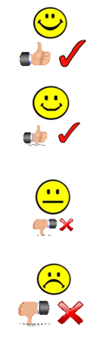

Somewhat satisfied

Neither satisfied nor dissatisfied

Somewhat dissatisfied

Very dissatisfied


- Please tell us what difference Short Breaks made to your child:

- Please tell us what difference Short Breaks made to you:

- Is there anything you particularly like about current Short Breaks provision or that works well?

- Is there anything that you don’t like or that could be improved?
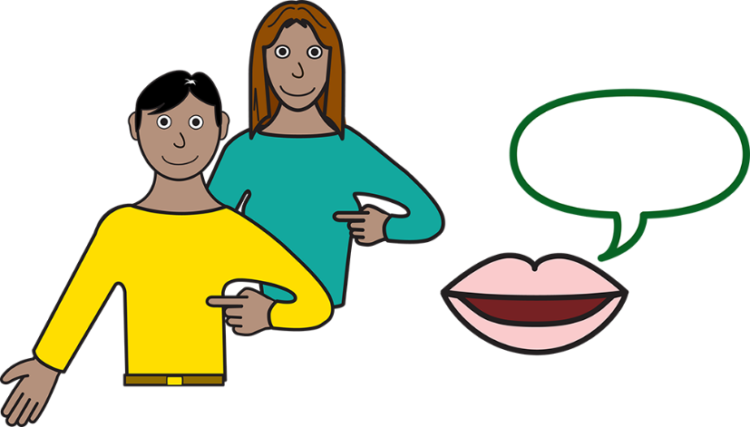
- Do you have any ideas for how future Short Breaks provision should be designed to best meet the needs of children and families?

- Please use the space below for anything else you would like to tell us about Short Breaks.

How we will use your information
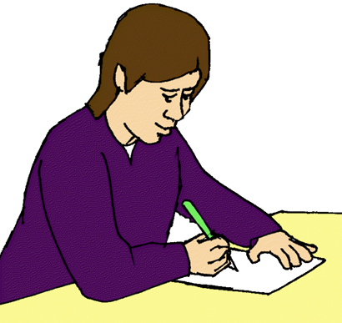
We will follow the Law to keep information about you safe and private.

We will use your answers to help us with our work on the Shropshire SEND Information, Advice and Support Service. We will not share your information with anyone else. We will delete your information when we don’t need it any more (there are rules we must follow under the Law and rules set by Shropshire Council).

When we report the results of this survey, we will not include any personal information, only a summary of everyone’s answers. You can find out more about how we protect your information here: www.shropshire.gov.uk/privacy

Thank you for taking this survey!
To return this survey, you can post it or drop it off to us at:
Feedback and Insight Team, Shropshire Council, Shirehall, Abbey Foregate, Shropshire SY2 6ND.
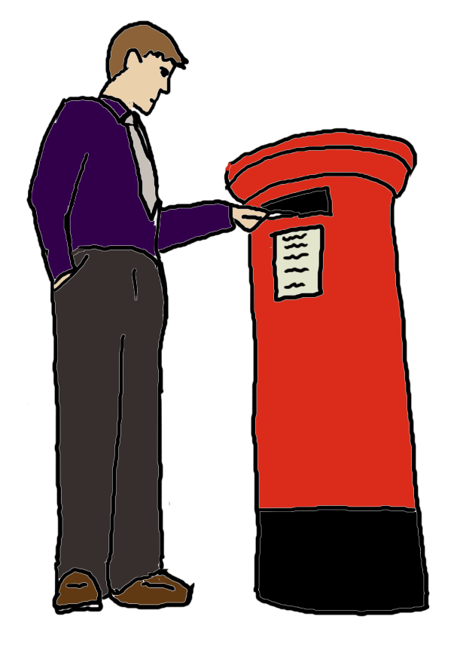
You can also scan or take a photo of the survey and email it to us at:
tellus@shropshire.gov.uk.

You need to return this survey to us by 12th June 2024.
Images are from the Valuing People Clipart Collection
(Inspired Services Publishing 2009). www.inspiredservices.org.uk

