

Future of Oak Farm
Survey

We want to know what you think

July 2024



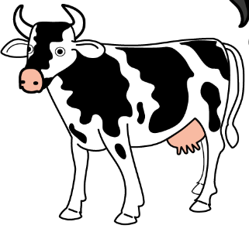
Introduction

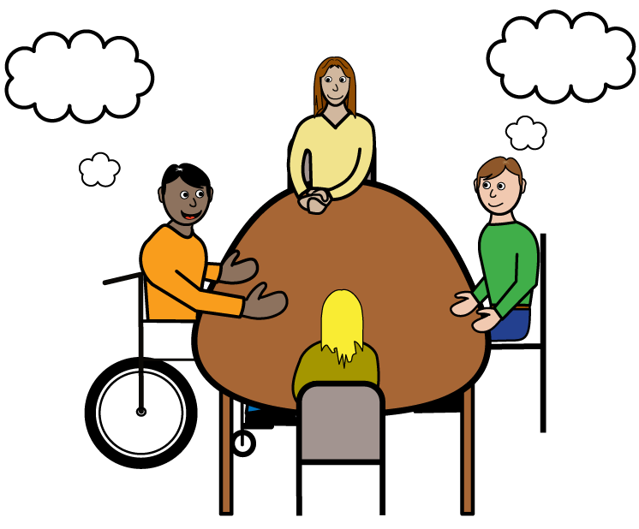 | Do you know?  Oak Farm currently supports adults with learning and physical disabilities. The service is run by Bethphage.  Bethphage will soon move to another farm that they have bought. This means that things will change and Shropshire Council wants to find out what to do next.
 | We are asking people who visit Oak Farm, their families and others, what they would like to see in the future.
We want to know what you think
about our suggestions which will inform what to do next.

 | There are no right or wrong answers. We are just interested in what you think.  You can email us at tellus@shropshire.gov.uk if you need any help or have any other comments.
 | You can tell us what you think by  ticking the boxes on this form or alternatively by completing an online survey: https://www.surveymonkey.com/r/OakFarm  You have until 2nd September 2024 to tell us what you think.
Our plans
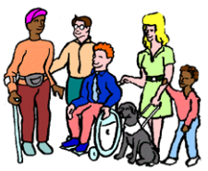 | We need to make the best use of the money we have available to support people.  Shropshire Council needs to decide what will happen next at Oak Farm. To do that we need to know what you think about different options.
   | Options
- Oak Farm services close and individuals are supported in other ways / at different venues
Good conversations and reviews will be undertaken to find alternative provision for each person currently visiting Oak Farm. This may include the new farm run by Bethphage, or other services and support based in communities across Shropshire.

- Find a new organisation to run Oak Farm
(with agreement from the landowner)
Individuals continue to be supported at Oak Farm with a new provider. It may not be easy to find a new provider who is interested or able to deliver the services in the time we have or have the demand for another service.

- Support continues through an agreed move to the new farm.
Plans are made for individuals who are supported at Oak Farm to move across to the new Bethphage owned farm site.
Note - within this option individuals will be able to explore other types of support if they don’t want to move to the new site and this will be supported through a review.
 | We will use your comments and if we make changes they will be agreed once the survey closes. We will make sure that you are kept updated of any changes, this will be in the Autumn time.
Oak Farm
- Do you use the services at Oak Farm?
Please tick (ü) 1 box



- How far do you travel to Oak Farm?
Please tick (ü) one box

I don’t travel to Oak Farm

Less than 4 miles

Between 4 and 10 miles

More than 10 miles
I don’t know

- How do you get there?

Please tick (ü) as many boxes as you need to

I don’t travel to Oak Farm

Car, taken by my family

Taxi (paid for by my family)

Transport organised by Shropshire Council
Walk, bike, wheelchair (outdoors travel)
Bus
Transport provided by Bethphage
Community transport with volunteers
Other

Your thoughts

- Which of the three options do you prefer? Please tick (ü)

- Oak Farm services close Oak Farm services close and individuals are supported in other ways / at different venues

- Find a new organisation to run Oak Farm
(with agreement from the landowner)

3) Support continues through an agreed move to the new farm.

- Do you have any comments about the option you chose?

- If Oak Farm closes, what will that mean for you?

- Do you know about other day opportunities in Shropshire you could use?

Please tick (ü) 1 box

- Do you have any suggestions for meeting your needs in future?

- Please use this space for any comments.
About You
- Do you have a disability?
Please tick (ü) 1 box

Yes

No

I’d rather not say

- Are you… ?
Please tick (ü) 1 box

A girl / woman

A boy / man

Other (e.g I self-describe)

I’d rather not say

- What is your ethnic background?

Please tick (ü) as many boxes as you need to

White (British; Irish; Welsh)

White (Gypsy, Roma or Irish traveller)

Other white background e.g. Bulgarian, French, Lithuanian, Polish, Portuguese, White South African, etc.

Asian (Asian British; Bangladeshi Chinese; Indian; Japanese; Pakistani; any other Asian background).
Black (Black African; Black British; Black Caribbean; any other Black background).
Arab
Other Ethnic Group
Prefer not to say or don’t know

- What is your postcode?
We won’t use this to find out where you live, only to check that people living in different areas of Shropshire have been able to share their comments.

- Which of these describe you?

Please tick (ü) as many boxes as you need to

I go to school or college in Shropshire

I work in Shropshire

I live in Shropshire
I represent a community or voluntary group

Other

- How old are you?
Please tick (ü) one box

Under the age of 18

18 to 21

22 to 40
41 to 60
61 and older

Prefer not to say

How we will use your information


We will follow the Law to keep information about you safe and private.

We will use your answers to help us with our work on home to school and college transport. We will not share your information with anyone else. We will delete your information when we don’t need it any more (there are rules we must follow under the Law and rules set by Shropshire Council).

When we report the results of this survey, we will not include any personal information, only a summary of everyone’s answers. You can find out more about how we protect your information here: www.shropshire.gov.uk/privacy

Thank You
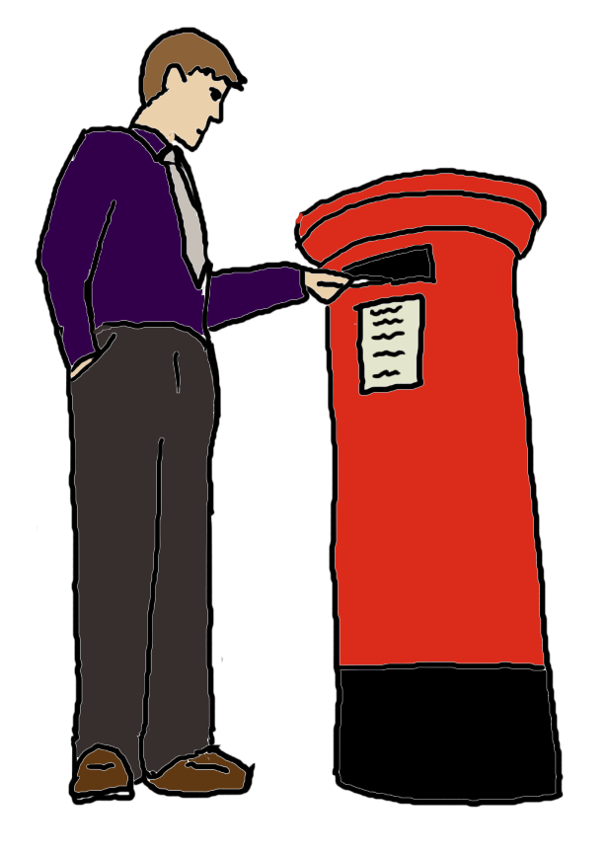
Now please post this back to us in the envelope we sent you.
You do not need to put a stamp on it.

You need to post it back to us by 2nd September 2024.

Images are from the Valuing People Clipart Collection
(Inspired Services Publishing 2009). www.inspiredservices.org.uk
And Easy on the i
(NHS Leeds and York Partnership NHS Foundation Trust)
Image Bank - Learning Disability Service (learningdisabilityservice-leeds.nhs.uk)

